A

Mini Project Report on

# JYOTIRLINGA’S OF BHARATH

Submitted for partial fulfilment of the requirements for the award of the degree of

## BACHELOR OF ENGINEERING

in

## INFORMATION TECHNOLOGY

by

**Aitha .Vaishnavi** (2451-22-737-058)

**Enuganti.Vaishnavi** (2451-22-737-063)

**Musku Ashwitha Reddy** (2451-22-737-064)

Under the guidance of

## Mr.P.Karthik

Assistant Professor

Department of IT



## MATURI VENKATA SUBBA RAO (M.V.S.R) ENGINEERING COLLEGE (An Autonomous Institute)

Department of Information Technology

(Affiliated to Osmania University & Recognized by AICTE)

Nadergul, Saroor Nagar Mandal, Hyderabad– 501 510

AY : 2023-2024

i



## CERTIFICATE

*This is to certify that the mini project work entitled “****Handicrafts of Bharat****” is a bonafide work carried out by Ms.Aitha.Vaishnavi (2451-22-737-058), Ms.Enuganti.Vaishnavi (2451-22-737-063), Ms.Musku.Ashwitha (2451-22-737-064) in partial fulfilment of the requirements for the award of degree of Bachelor of Engineering in Information Technology from Maturi Venkata Subba Rao (M.V.S.R.) Engineering College, an Autonomous Institution, affiliated to Osmania University Hyderabad, during the Academic Year 2023-24 under our guidance and supervision.*

*The results embodied in this report have not been submitted to any other university or institute for the award of any degree or diploma.*

|  |  |
| --- | --- |
| **Internal Guide** | **Project Co-ordinator** |
| **Mr.P.Karthik** | **M.Swapna** |
| Assistant Professor | Assistant Professor |
| Department of IT | Department of IT |
| MVSREC | MVSREC |
| **HOD** | **External Examiner** |

## Dr.K.Venugopala Rao

Dean–Academics, Professor & Head

Department of IT

MVSREC

ii

## DECLARATION

This is to certify that the work reported in the present miniproject work entitled “**Jyotirlinga’s of Bharat**”is a record of bonafide work done by us in the Department of Information Technology, Maturi Venkata Subba Rao (M.V.S.R.) Engineering College, an Autonomous Institution, affiliated to Osmania University. The reports are based on the project work done entirely by us and not copied from any other source.The results embodied in this project report have not been submitted to any other University or Institute for the award of any degree or diploma to the best of our knowledge and belief.

|  |  |  |
| --- | --- | --- |
| Aitha Vaishnavi | Enuganti Vaishnavi | Musku Ashwitha |
| (2451-22-737-058) | (2451-22-737-063) | (2451-22-737-064) |

iii

## ACKNOWLEDGEMENT

We would like to express our sincere gratitude to our Project Guide  **Mr.P.Karthik**, Assistant Professor for his valuable suggestions and interest throughout the course of this project.

We would like to express our sincere gratitude and indebtedness to our Project Co-ordinator **M.Swapna**, Assistant Professor- Department of Information Technology, for her valued recommendations and attention throughout the course of this project.

We wish to extend our heart felt gratitude and deep appreciation to our esteemed Professor Dr. H. Jayasree- Department of Information Technology for her invaluable guidance and unwavering support throughout the duration of this project.

We are also thankful to our Principal **Dr. G. Kanaka Durga**, **Professor** , **Dr. K. Venugopala Rao,** Professor and Head - Department of Information Technology, Dean-Academics, Maturi Venkata Subba Rao Engineering College, for providing excellent infrastructure and a nice atmosphere for completing this project successfully as a part of our B.E. Degree (IT).

We convey our heartfelt thanks to the lab staff for allowing us to use the required equipment whenever needed.

Finally, we would like to take this opportunity to thank our family for their support through the work. We sincerely acknowledge and thank all those who gave directly or indirectly their support in the completion of this work.

Aitha Vaishnavi (2451-22-737-058)

Enuganti Vaishnavi(2451-22-737-063)

Musku Ashwitha Reddy (2451-22-737-064)

iv

## VISION & MISSION, PROGRAM EDUCATIONAL OUTCOMES

**Vision of the Department:**

To impart technical education producing competent and socially responsible engineering professionals in the field of Information Technology.

**Mission of the Department:**

M1.To make teaching learning process effective and stimulating.

M2.To provide adequate fundamental knowledge of sciences and Information Technology with positive attitude.

M3.To create an environment that enhances skills and technologies required for industry.

M4. To encourage creativity and innovation for solving real world problems.

M5.To cultivate professional ethics in students and inculcate a sense of responsibility towards society

**Program Educational Objectives**:

After 3 to 4 years of graduation, graduates of the Information Technology program will:

1. Apply knowledge of mathematics and Information Technology to analyze, design and implement solutions for real world problems in core or in multidisciplinary areas.
2. Communicate effectively, work in a team, practice professional ethics and apply knowledge of computing technologies for societal development.
3. Engage in Professional development or postgraduate education to be a life-long learner.

v

**PROGRAM OUTCOMES & PROGRAM SPECIFIC OUTCOMES**

## PROGRAM OUTCOMES (POs)

**Engineering Graduates will be able to:**

1. **Engineering knowledge**: Apply the knowledge of mathematics, science, engineering fundamentals, and an engineering specialization to the solution of complex engineering problems.
2. **Problem analysis**: Identify, formulate, review research literature, and analyze complex engineering problems reaching substantiated conclusions using first principles of mathematics, natural sciences, and engineering sciences.
3. **Design/development of solutions**: Design solutions for complex engineering problems and design system components or processes that meet the specified needs with appropriate consideration for the public health and safety, and the cultural, societal, and environmental considerations.
4. **Conduct investigations of complex problems**:Use research-based knowledge and research methods including design of experiments, analysis and interpretation of data, and synthesis of the information to provide valid conclusions.
5. **Modern tool usage**:Create, select, and apply appropriate techniques, resources, and modern engineering and IT tools including prediction and modeling to complex engineering activities with an understanding of the limitations.
6. **The engineer and society**: Apply reasoning informed by the contextual knowledge to assess societal, health, safety, legal and cultural issues and the consequent responsibilities relevant to the professional engineering practice.
7. **Environment and sustainability**: Understand the impact of the professional engineering solutions in societal and environmental contexts, and demonstrate the knowledge of, and need for sustainable development.
8. **Ethics**: Apply ethical principles and commit to professional ethics and responsibilities and norms of the engineering practice.
9. **Individual and team work**: Function effectively as an individual, and as a member or leader in diverse teams, and in multidisciplinary settings.
10. **Communication**: Communicate effectively on complex engineering activities with the engineering community and with society at large, such as, being able to comprehend and write effective reports and design documentation, make effective presentations, and give and receive clear instructions.
11. **Project management and finance**: Demonstrate knowledge and understanding of the engineering and management principles and apply these to one’s own work, as a member and leader in a team, to manage projects and in multidisciplinary environments.
12. **Life-long learning**: Recognize the need for, and have the preparation and ability to engage in independent and life-long learning in the broadest context of technological change.

**PROGRAM SPECIFIC OUTCOMES (PSOs):**

PSO1: **Hardware design**: An ability to analyze, design, simulate and implement computer hardware / software and use basic analog/digital circuits, VLSI design for various computing and communication system applications.

PSO2:S**oftware design**: An ability to analyze a problem, design algorithm, identify and define the computing requirements appropriate to its solution and implement the same.

vi

## COURSE OBJECTIVES & COURSE OUTCOMES COURSE OBJECTIVES

* Enable students learning by doing.
* Develop capability to analyse and solve real time problems.
* Inculcate innovative ideas.
* Impart team building and management skills.
* Instil writing and presentation skills.

## COURSE OUTCOMES

After completion of the course student will be able to:

CO1-Interpret Literature with the purpose to formulate a problem statement.

CO2 - Plan, Analyze, Design and implement a project.

CO3-Find the solution of identified problem with the help of modern tools & technology.

CO4 - Plan to work as a team to exhibit team skills to meet deadlines.

CO5 - Prepare and submit the Report and deliver presentation.

vii

## ABSTRACT

Exploring the Dwadasa Jyotirlingas in India is a spiritual and cultural journey of immense significance. These twelve sacred shrines dedicated to Lord Shiva are spread across the country, each possessing a unique historical and mythological significance. Pilgrims embark on this sacred trail to seek divine blessings and experience the rich tapestry of Indian spirituality.From the iconic Somnath in Gujarat to the mystical Kashi Vishwanath in Varanasi, the Dwadasa Jyotirlingas showcase diverse architectural styles and regional flavors. Pilgrims navigate through vibrant landscapes, witnessing the amalgamation of religious fervor and architectural marvels. The journey encompasses spiritual rituals, holy dips in sacred rivers, and encounters with the cultural diversity of India.Whether it's the serene shores of Rameswaram or the Himalayan heights of Kedarnath, each Jyotirlinga narrates tales of devotion and divine intervention. Exploring these sacred sites offers not only a religious pilgrimage but also an exploration of India's deep-rooted spiritual heritage.

Aitha Vaishnavi (2451-22-737-058)

Enuganti Vaishnavi (2451-22-737-063)

Musku Ashwitha Reddy (2451-22-737-064)

Viii

**TABLE OF CONTENTS**

**CONTENTS**  **PAGE NO**

Certificate i

Declaration ii

Acknowledgement iii

Vision & Mission, PEOs iv

POs and PSOs v

Course Objectives & Outcomes vi

Abstract vii

Table of Contents viii

List of Figures ix

Chapters

1. **Introduction** 1
   1. Problem statement
   2. Existing system
   3. Proposed system
   4. Scope
2. **System Requirement Specifications** 2
   1. Software Requirements
   2. Hardware Requirements
   3. System Architecture / Block Diagram
3. **Design & Implementation** 3-7
   1. Features
   2. Environmental Setup
4. **Test Cases & Results** 8-11
   1. Test Cases
   2. Results

**1 Conclusion & Future Enhancements** 12

**References**  13

**Appendix**  14-16

**A: source/pseudo code**

ix **TABLE OF FIGURES**

|  |  |  |
| --- | --- | --- |
| **Figure No.** | **Figure Name** | **Page No.** |
| Fig-2.3.1 | System Architecture | 2 |
| Fig-3.2.1 | Visual Code Installation | 3 |
| Fig-3.2.2 | Vs Code Icon | 4 |
| Fig-3.2.3 | License Agreement | 4 |
| Fig-3.2.4 | Additional Task | 5 |
| Fig-3.2.5 | App Installation | 5 |
| Fig-3.2.6 | Vs Code Setup | 6 |
| Fig-3.2.7 | Vs Code Setup Wizard | 6 |
| Fig-3.2.8 | Vs Code Welcome Page | 7 |
| Fig-4.1 | Home Page | 10 |
| Fig-4.2 | Exploring Map | 10 |
| Fig-4.3 | Map Page | 11 |
| Fig-4.4 | Information Page | 12 |
| Fig -4.5 | Gallery Page | 12 |
| Fig4.6 | Sloka Page | 13 |
| Fig-4.7 | About Page | 13 |

# CHAPTER 1 INTRODUCTION

According to the Shiva Purana, Brahma and Vishnu disputed their supremacy. Shiva intervened by manifesting as an infinite pillar of light, the jyotirlinga. Brahma and Vishnu attempted to find its end, with Brahma falsely claiming success by presenting a ketak flower, while Vishnu confessed failure. Shiva cursed Brahma for his deceit, declaring Vishnu to be eternally worshipped for his honesty. The jyotirlinga shrines represent Shiva's appearance as a divine column of light.

## PROBLEM STATEMENT

Develop a user friendly website for showcasing Jyotirlinga’s of Bharat, incorporating an interactive map.Address the challenge of limited information by providing a platform that only highlights the diverse shivlinga’s and their significance but also ensures an engaging and informative user experience.

## 1.2 EXISTING SYSTEM

The existing system consists of a website that showcases the 12 Jyotirlingas of India on an India map. Additionally, it represents these sacred sites in a tabular format, providing organized information for usersThrough both visual and tabular presentations, the website offers comprehensive insight into these significant religious landmarks scattered across the country

## 1.3 PROPOSED SYSTEM

The proposed system entails a website that highlights each Jyotirlinga of India individually on a map. Upon hovering over a specific Jyotirlinga on the map, a new webpage opens, offering a brief explanation and significance of that particular site. Furthermore, the website provides precise geographical coordinates (latitude and longitude) for each Jyotirlinga, aiding users in locating them with accuracy. It also delves into the architectural features of each temple housing the Jyotirlinga and elucidates the various methods of worship associated with each sacred site. With user-friendly navigation and comprehensive information, this system aims to offer a rich and immersive experience for visitors seeking knowledge and understanding of these revered landmarks.

## 1.4 SCOPE

Goal: Learn and share about Bharat’s twelve sacred Jyotirlingas.

Research: Find out the stories,history,and importance of each jyotirlinga.

Understand Culture: Learn about the festivals,rituals,and traditions connected to each

Jyotirlinga.

**CHAPTER 2**

# SYSTEM REQUIREMENT SPECIFICATIONS

## 2.1 SOFTWARE REQUIREMENTS

* Operating System - Windows
* Front End - HTML,CSS
* IDE - Visual Code Studio

## 2.2 HARDWARE REQUIREMENTS

* Processor - I7/Intel Processor
* RAM - 8GB
* Hard Disk - 160GB

## 2.3 SYSTEM ARCHITECTURE

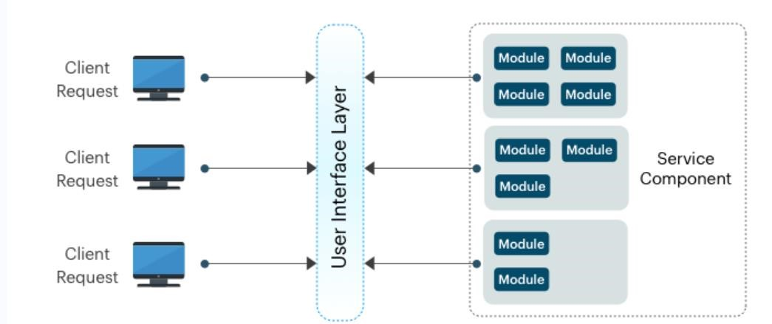

Fig-2.3.1 System Architecture

**CHAPTER 3**

# DESIGN AND IMPLEMENTATION

## 3.1 FEATURES

* **Interactive India Map:** Incorporate an interactive map of India on the homepage, where users can click on individual states to access information about the handicrafts specific to that region.
* **Specific Pages for Each Jyotirlinga:** Create dedicated pages for each Jyotirlinga, providing detailed information about the formation of jyotirlinga, its significance, worshipping rituals associated with it, Timings, Transportation and a Sloka.
* **High-Quality Imagery:** Include high quality images of the jyotirlinga’s, and incorporate multimedia elements like videos showcasing the story behind the formation of jyotirlinga.
* **Audio Support:** Provide Audio support so that it would be easy for the users to access it.

**3.2 ENVIRONMENTAL SETUP**

Installing An Editor: Visual Studio (VS) Code

1. Visit the official website of the Visual Studio Code using any web browser like Google Chrome, Microsoft Edge, etc.
2. Press the “**Download for Windows**” button on the website to start the download of the Visual Studio Code Application.

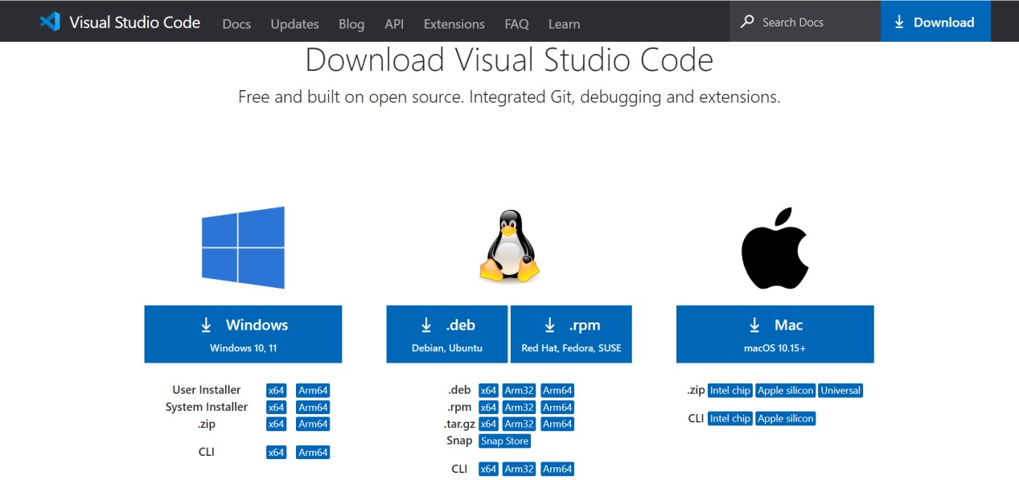

Fig-3.2.1 Visual Code Installation

1. When the download finishes, then the Visual Studio Code icon appears in the downloads folder.



Fig-3.2.2 Vs Code Icon

1. Click on the installer icon to start the installation process of the Visual Studio Code. After the Installer opens, it will ask you for accepting the terms and conditions of the Visual Studio Code. Click on **I accept the agreement** and then clickthe **Next** button.



Fig-3.2.3 License Agreement

1. Choose the location data for running the Visual Studio Code. It will then ask you for browsing the location. Then click on **Next** button.

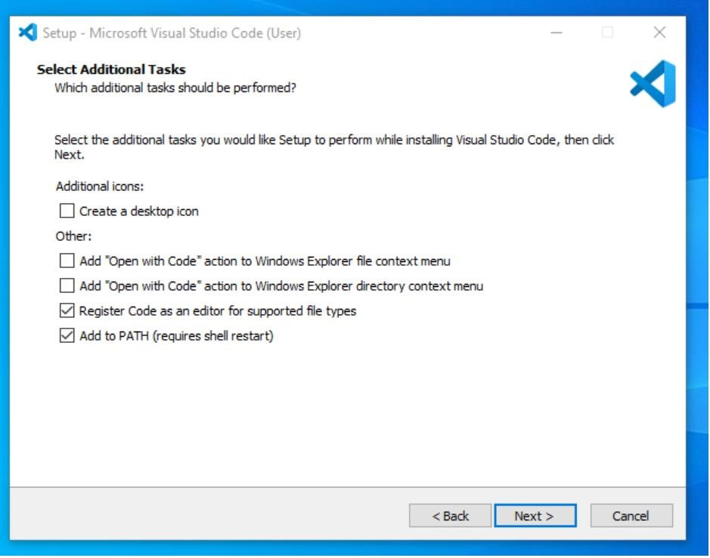

Fig-3.2.4 Adiitional Task

1. Then it will ask for beginning the installing setup. Click on the **Install** button.

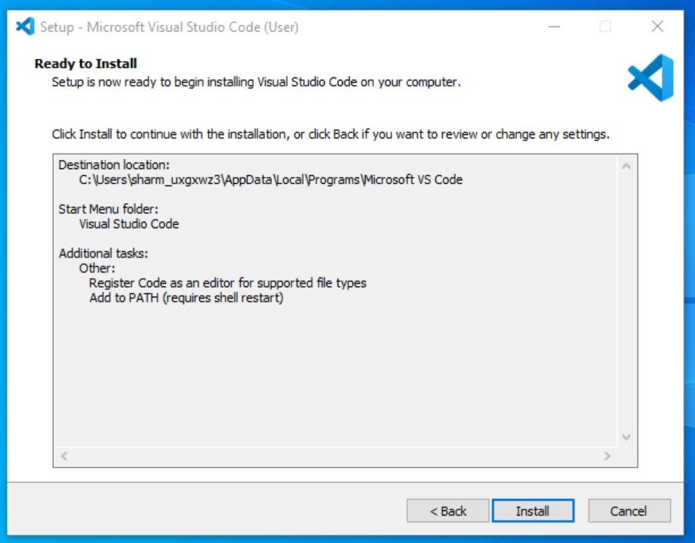

Fig-3.2.5 App Installation

1. After clicking on Install, it will take about 1 minute to install the Visual Studio Code on your device.

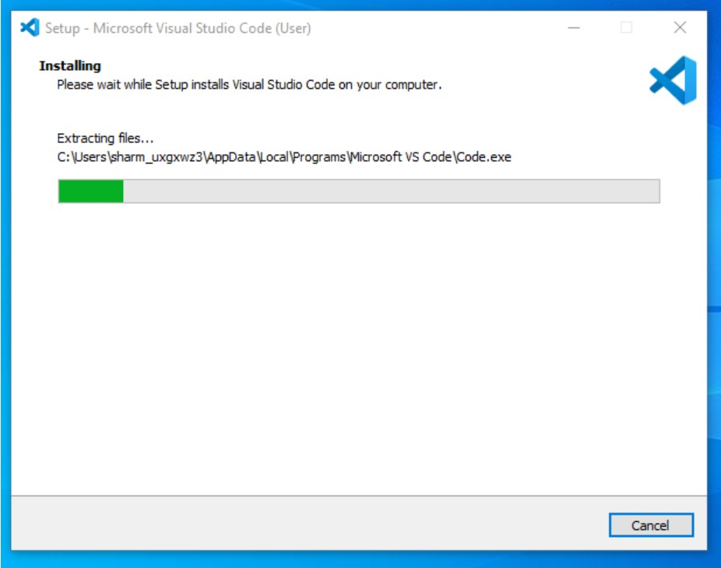

Fig-3.2.6 Vs Code Setup

1. After the Installation setup for Visual Studio Code is finished, it will show a window like this below. Tick the “**Launch Visual Studio Code**” checkbox and then click **Next.**

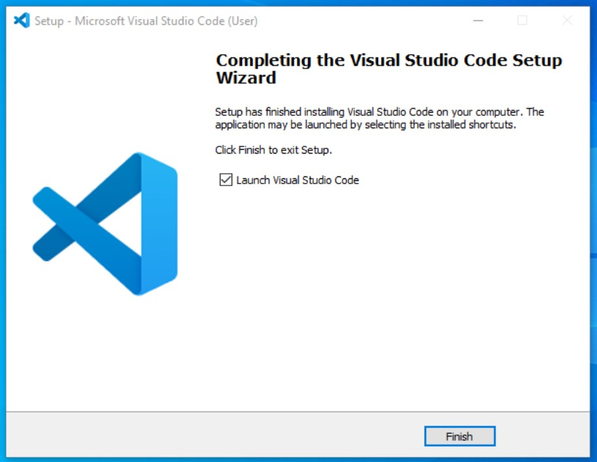

Fig-3.2.7 Vs Code Setup Wizard

1. After the previous step, the **Visual Studio Code window** opens successfully. Now you can create a new file in the Visual Studio Code window and choose a language of yours to begin your programming journey!

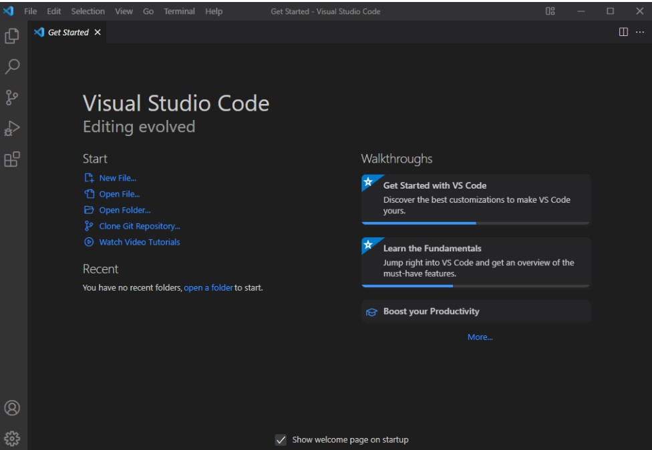

Fig-3.2.8 Vs Code Welcome Page

So this is how we successfully installed **Visual Studio Code** on our Windows system

# CHAPTER 4

**TEST CASES AND RESULTS**

## 4.1 TEST CASES

|  |  |  |  |  |  |
| --- | --- | --- | --- | --- | --- |
| **Test Case No.** | **Test Case**  **Name** | **Test Case Description** | **Test Case**  **Input** | **Test Case**  **Output** | **Test Case**  **Status** |
| 1 | Home Page | Displays a home page  with a nav bar and Map tag indulged in nav bar which redirects to map page. | Click on  Map button | Opens map page | Pass |
| 2 | Interactive map and 3d image of each jyotirlinga on map | Displays India map and 3d image of jyotirlinga along with name when we hover on it. | Click or hover on specific image or name of jyotirlinga. | Opens  Information  Page | Pass |
| 3 | Audio Button | Makes the following text to be read | Click on the button | Reads the information of particular part. | Pass |
| 4 | Video | Displays a more info button on home page | Click on the button | Plays the making  video formation of jyotirlinga | Pass |

# 4.2 RESULTS

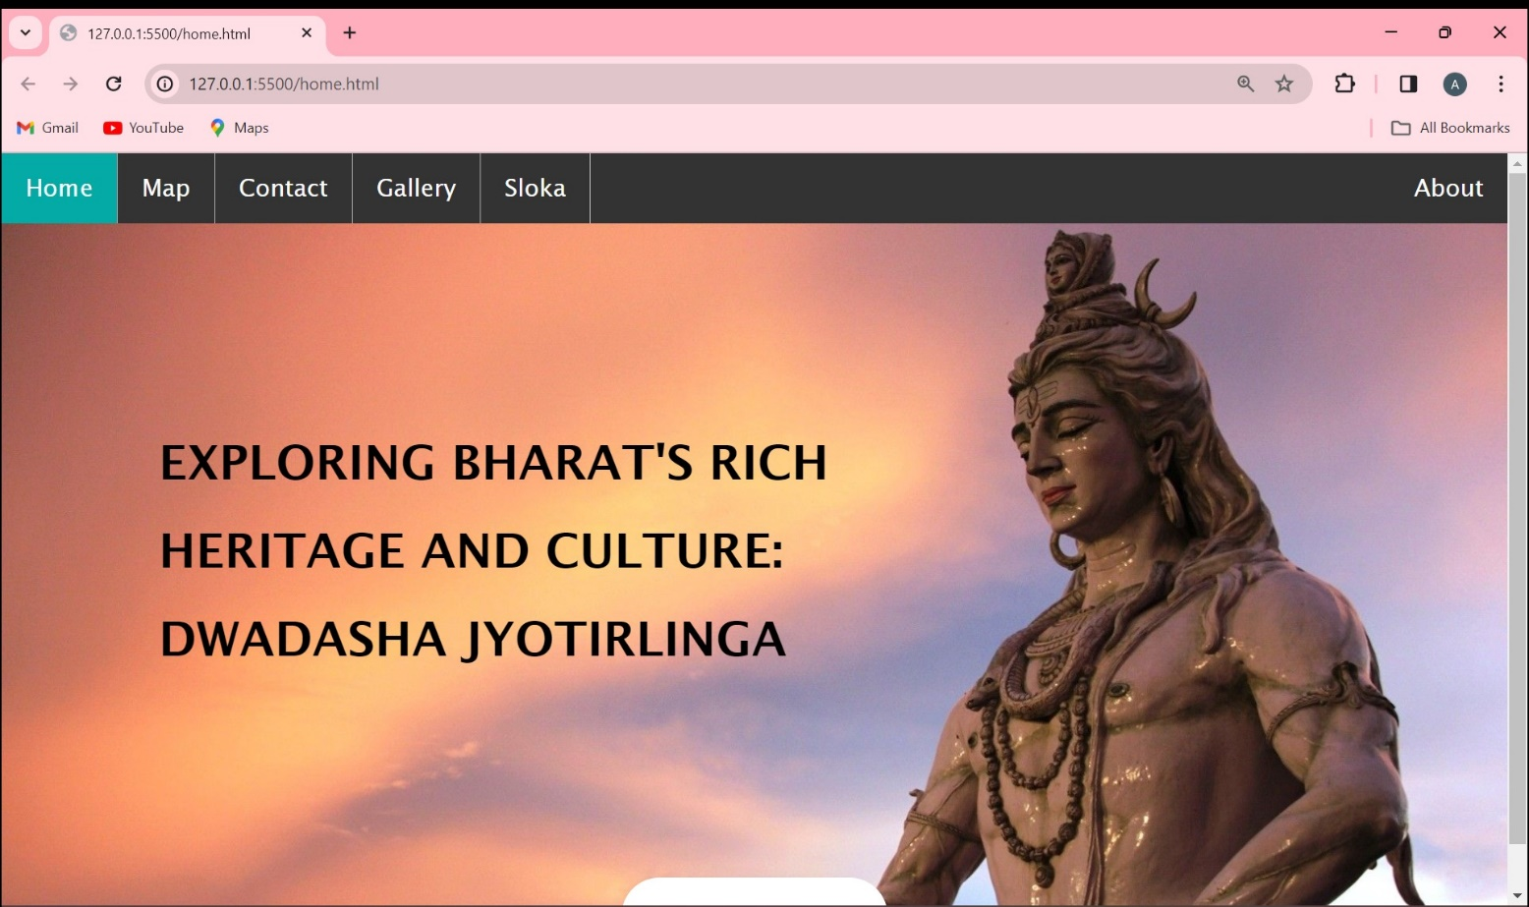

Fig-4.1 Home page

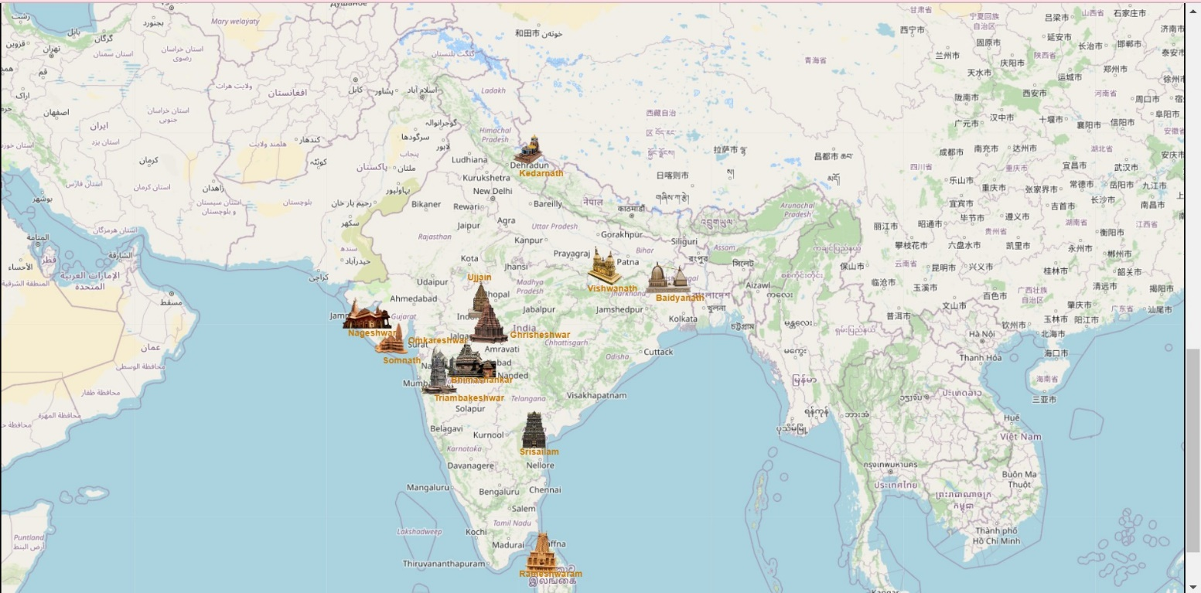Fig-4.2 Exploring Map

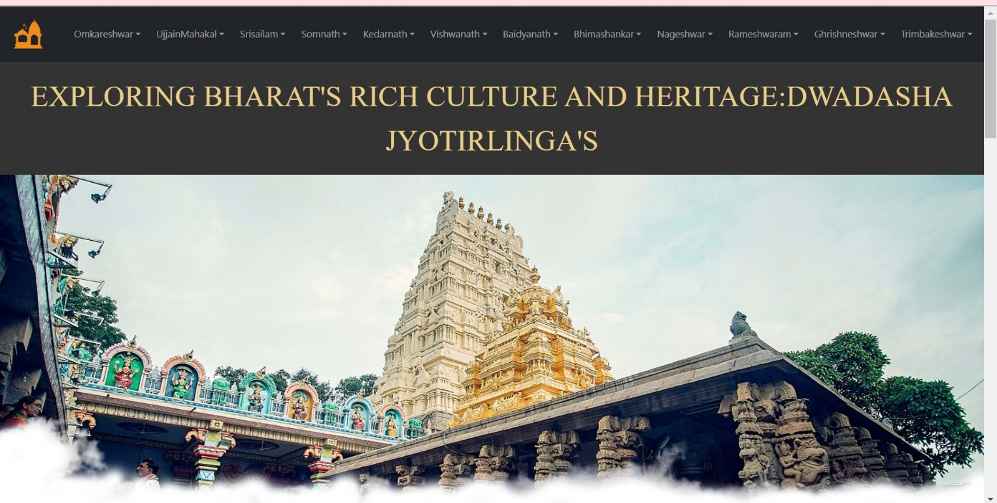

Fig-4.3 Map Page

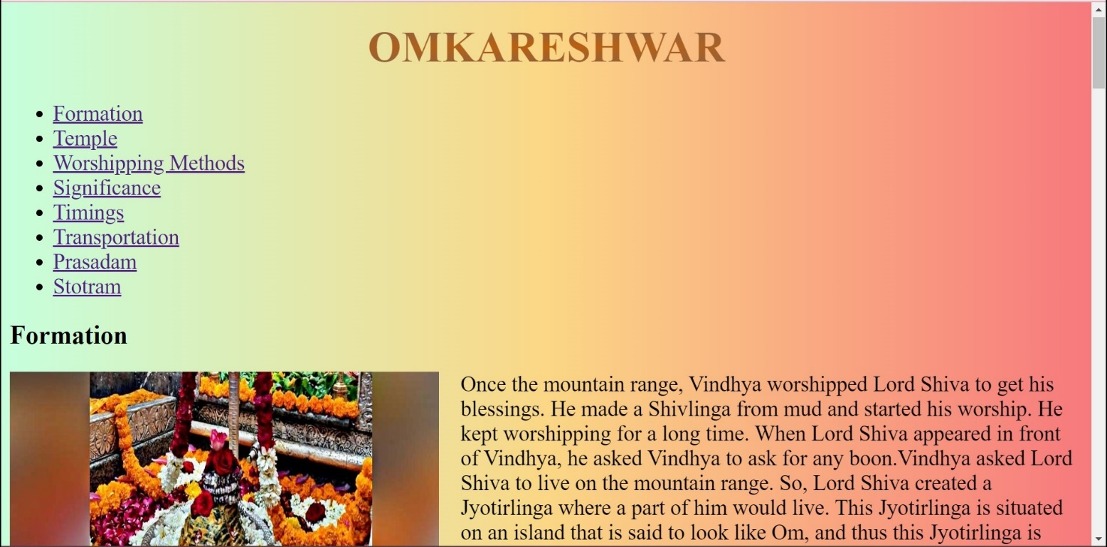

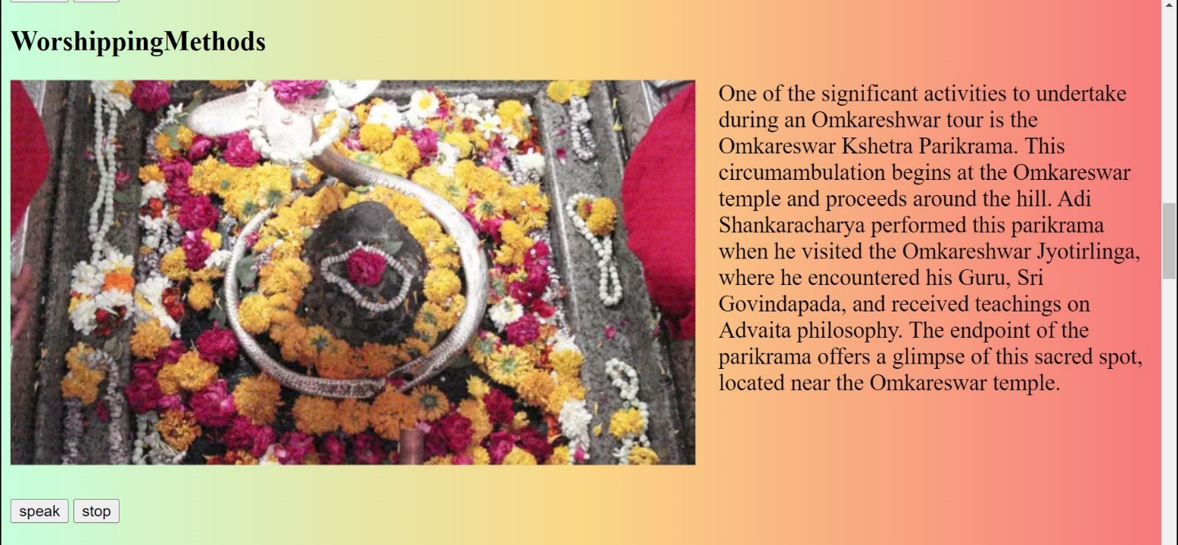

Fig-4.4 Information Page

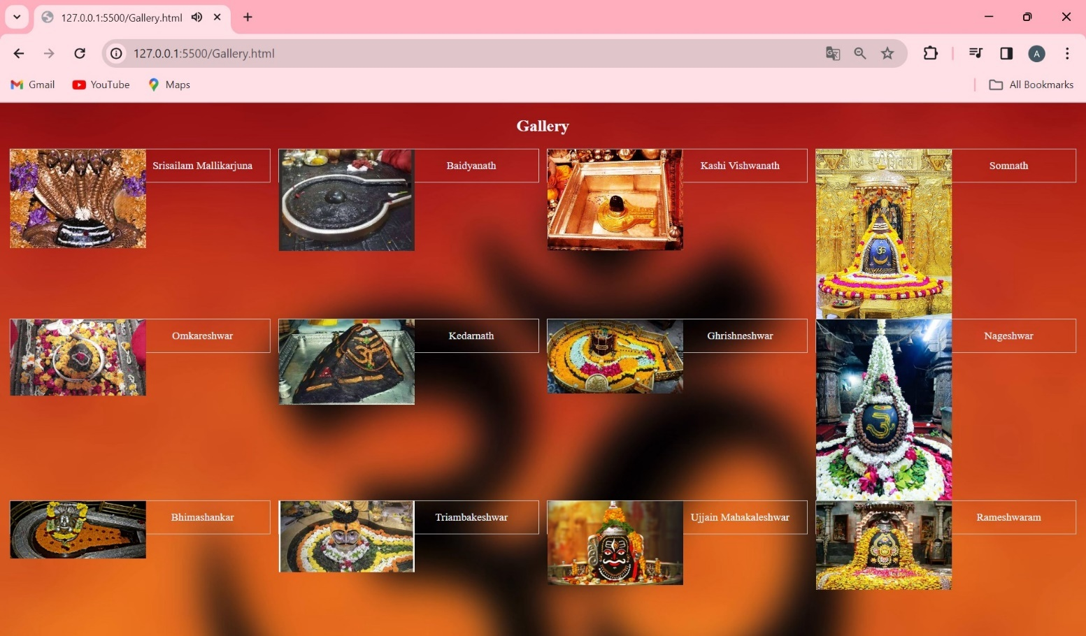

Fig-4.5 Gallery View

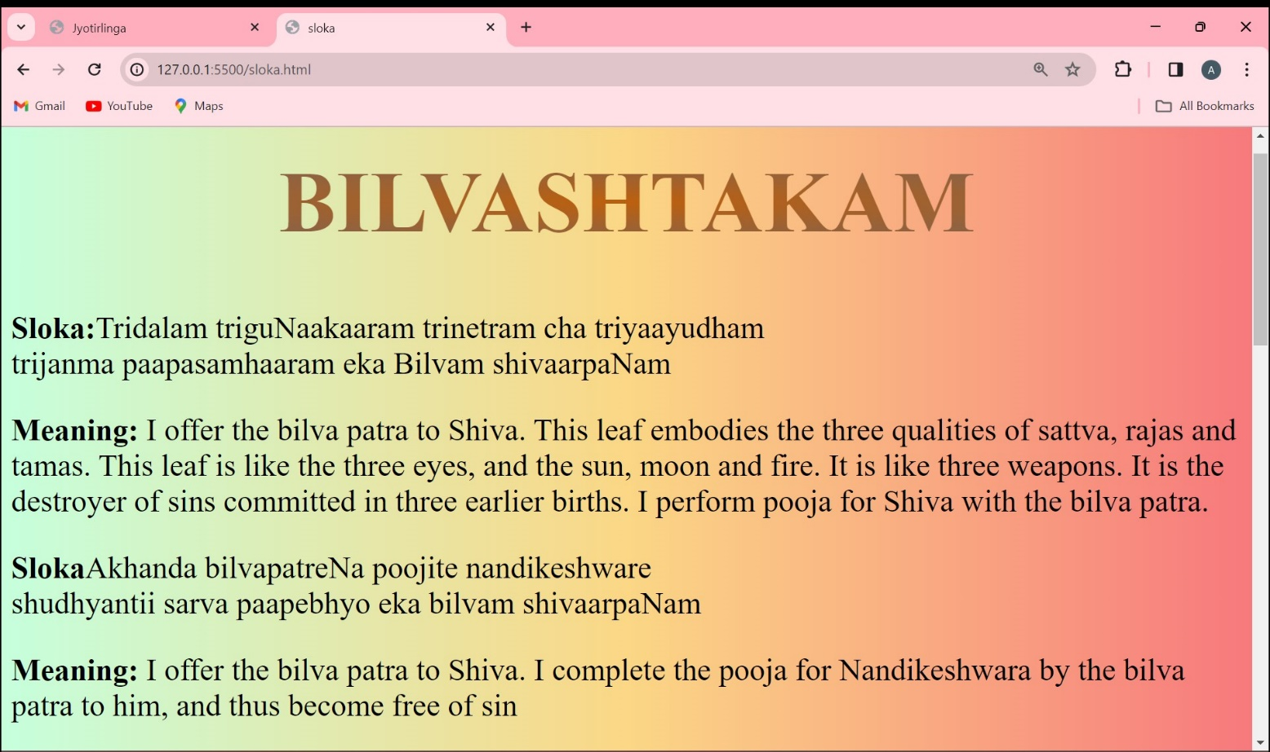

Fig-4.6 Sloka Page

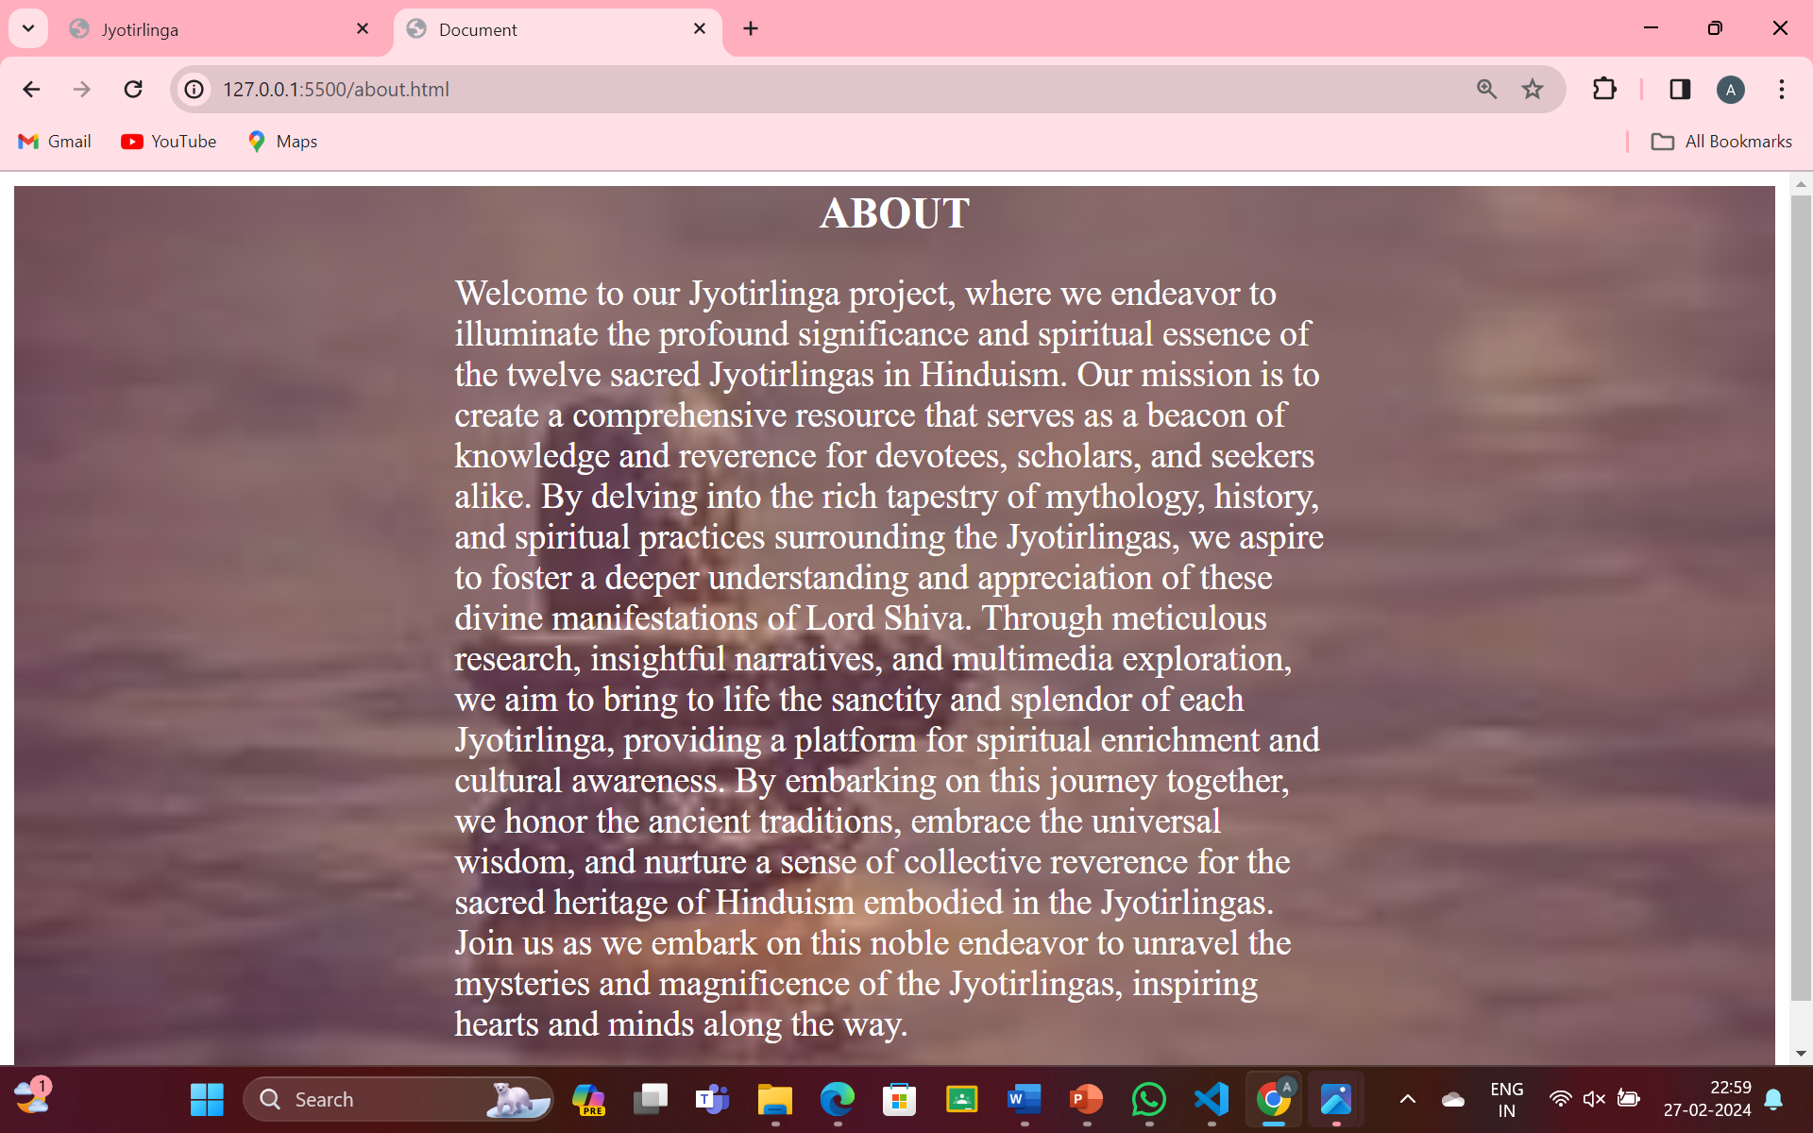

Fig-4.7 About Page

# CHAPTER 5 CONCLUSION AND FUTURE ENHANCEMENTS

## 5.1 CONCLUSION

The application showcasing replicas of the integrated forms of each Jyotirlinga in Bharat provides a valuable resource for spiritual seekers, tourists, and devotees alike. By offering an immersive digital experience, it enables users to explore and connect with these sacred sites regardless of geographical constraints. Such an application not only fosters cultural understanding and appreciation but also serves as a convenient tool for pilgrimage planning and spiritual enrichment.The application showcasing replicas of the integrated forms of each Jyotirlinga in Bharat provides a valuable resource for spiritual seekers, tourists, and devotees alike. By offering an immersive digital experience, it enables users to explore and connect with these sacred sites regardless of geographical constraints. Such an application not only fosters cultural understanding and appreciation but also serves as a convenient tool for pilgrimage planning and spiritual enrichment.

## 5.2 FUTURE ENHANCEMENTS

1. Query Page:
   * Dedicated page for user queries.
   * Fields: Name, Email, Query Type, Message.
   * Facilitates contact for various purposes.
2. Search Bar:
   * Prominent location.
   * Keyword search for specific content.
   * Enhances navigation.
3. Feedback Form:
   * Allows users to share feedback.
   * Fields: Name, Email, Feedback Type, Message.

# REFERENCES

Jyotirlinga-wikipedia[: https://en.wikipedia.org/wiki/Jyotirlinga](C:\\Users\\vaish\\OneDrive\\Desktop\\projecct-1\\ https\\en.wikipedia.org\\wiki\\Jyotirlinga)

Holidify: https://www.holidify.com/pages/jyotirlingas-in-india-1628.html

# APPENDIX

